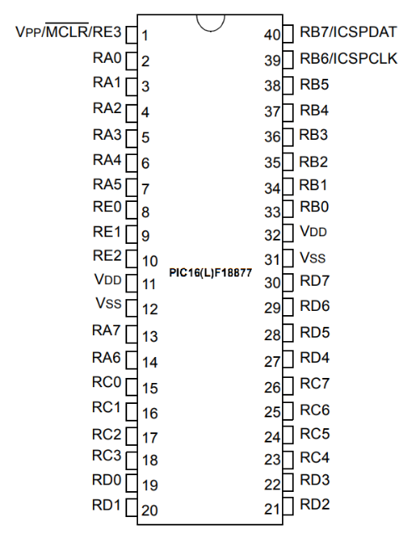**PINOUT**

|  |  |  |  |
| --- | --- | --- | --- |
| **PIN NO** | **PORT NO.** | **DIRECTION** | **FUNCTION** |
| 1 | RE3 | INPUT | R/W |
| 2 | RA0 | INPUT | Address 0 |
| 3 | RA1 | INPUT | Address 1 |
| 4 | RA2 | INPUT | Address 2 |
| 5 | RA3 | INPUT | Address 3 |
| 6 | RA4 | INPUT | Address 4 |
| 7 | RA5 | INPUT | Address 5 |
| 8 | RE0 | OUTPUT | Bus 0 |
| 9 | RE1 | OUTPUT | Bus 1 |
| 10 | RE2 | OUTPUT | Bus 2 |
| 11 | VDD | POWER | 5 volts |
| 12 | VSS | POWER | Ground |
| 13 | RA7 | INPUT | Address 7 |
| 14 | RA6 | INPUT | Address 6 |
| 15 | RC0 | - | - |
| 16 | RC1 | OUTPUT | SCK |
| 17 | RC2 | OUTPUT | SDO |
| 18 | RC3 | INPUT | SDI |
| 19 | RD0 | INPUT | SS |
| 20 | RD1 | INPUT | Address 8 |
| 21 | RD2 | INPUT | Address 9 |
| 22 | RD3 | INPUT | Address 10 |
| 23 | RC4 | INPUT | Address 11 |
| 24 | RC5 | INPUT | Address 12 |
| 25 | RC6 | OUTPUT | UTx |
| 26 | RC7 | INPUT | URx |
| 27 | RD4 | INPUT | Address 13 |
| 28 | RD5 | INPUT | Address 14 |
| 29 | RD6 | INPUT | Address 15 |
| 30 | RD7 | - | - |
| 31 | VSS | POWER | 5 volts |
| 32 | VDD | POWER | Ground |
| 33 | RB0 | BI-DIR | Data 0 |
| 34 | RB1 | BI-DIR | Data 1 |
| 35 | RB2 | BI-DIR | Data 2 |
| 36 | RB3 | BI-DIR | Data 3 |
| 37 | RB4 | BI-DIR | Data 4 |
| 38 | RB5 | BI-DIR | Data 5 |
| 39 | RB6 | BI-DIR | Data 6 |
| 40 | RB7 | BI-DIR | Data 7 |

